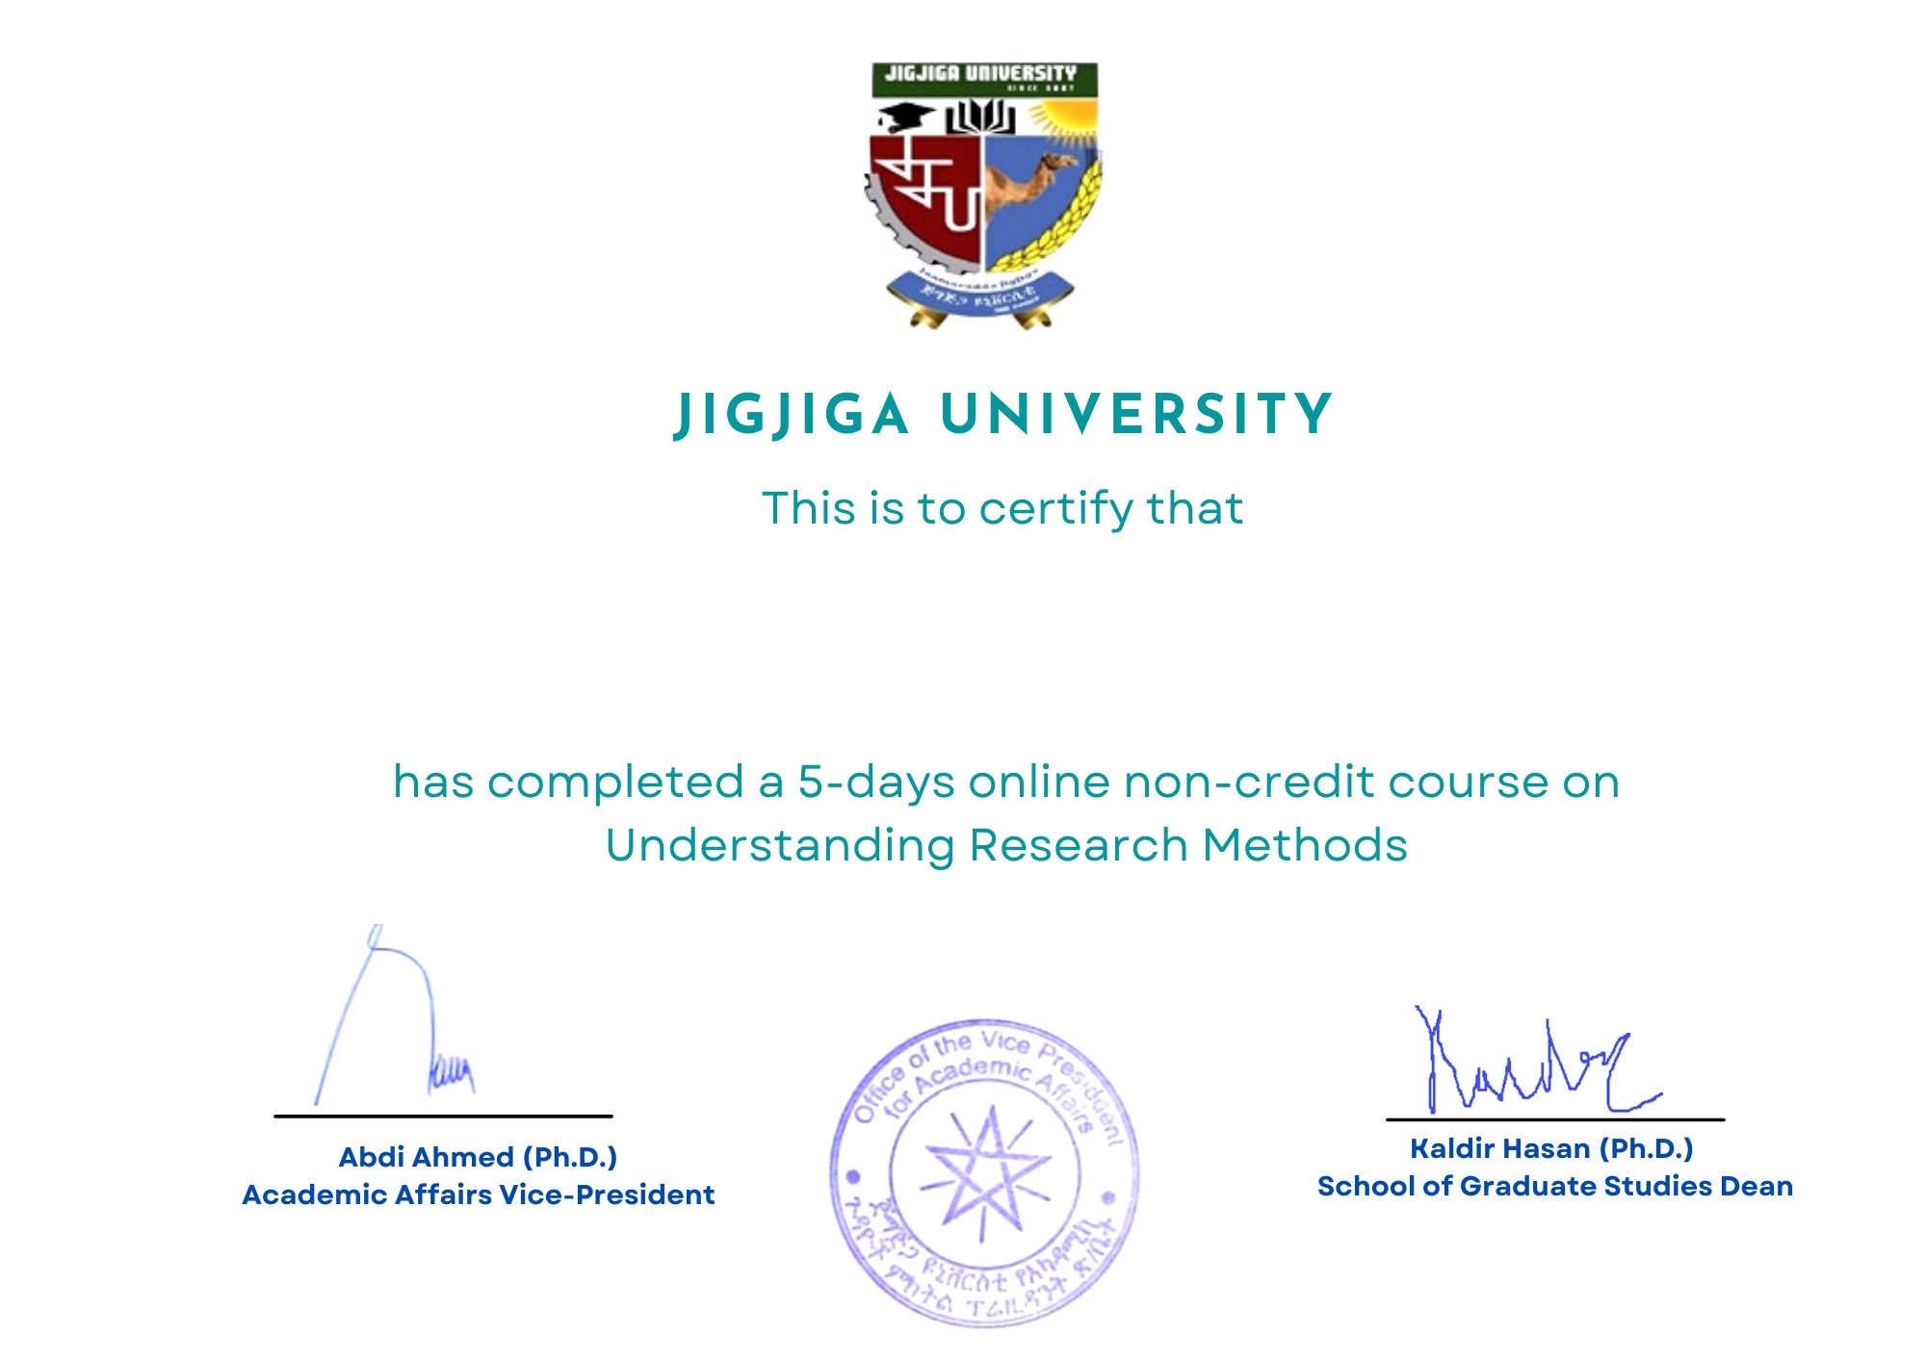

**ABDULAHI HERSI YUSUF**